|  |  |
| --- | --- |
| Your Name B.E [ Computer Science & Engineering ] | Phone : +91 – Phone Email : Your email id |
|  | Address : Address Line1  Address Line2 |

**Career Objective: **

My aim is to obtain professional and financial heights, both for the organization and self through my skills and knowledge, also to improve my skills continuously.



**Education**

|  |  |  |
| --- | --- | --- |
| 2015-19 | Bapuji Institute of Engineering & Technology, Davanagere | 6.7/10 |
|  | Bachelor of Engineering, Computer Science & Engineering | (5th - 8th sem) |
| 2015 | 12th(Senior Secondary Examination), Sri Chaithanya PU college, Bellary | 82.33% |
|  | State Board |  |
| 2013 | 10th (Secondary Examination), Sri Netaji Subhash Chandra Bose High School, Kudithini. 82.24% | |
|  | Secondary State Leaving Certificate |  |
|  |  |  |



**Projects**

|  |  |
| --- | --- |
| Mar-jun 2019 | **Traffic Pre emption for emergency vehicle** |
| Oct-Nov 2018 | **Website for Loan Management**(B.E Mini project 7thSemester) |
| Apr-May 2018 | **Aquarium** (B.E Mini project 6thSemester) |
| Nov-Dec 2017 | **RTO Management System** (B.E Mini Project, 5thSemester) |
|  |  |

**Technical Skills **

|  |  |
| --- | --- |
| DBMS | SQL |
| Languages | C,C++, CORE JAVA,J2EE |
|  |  |

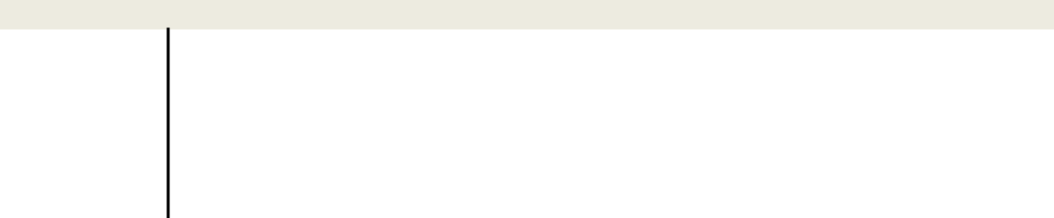

**Training & Workshops**

June 2019

July 2018

Feb 2017

Aug 2018

* Java trained from Jspiders.
* Internship on Cloud Computing in Krackin company.
* Attended Crash Course on C++ held for ten days.
* Internship project on Virtual Desktop Infrastructure.



**Extra Curricular Activities**

|  |  |
| --- | --- |
| April 2018-19 | Volunteer in the DAVANA-2k18 fest held in Bapuji institute of engineering. |
| April 2018 | Hosted the BPL cricket tournament in college. |
| Mar 2017 | Hosted branch fest conducted in Computer science and engineering Dept. |
|  |  |

**Personal Strengths **

* Good leadership quality and Trustworthy.
* Loyal towards the organisation.
* Manage to work in pressure condition.
* Able to work efficiently as a part of team as well as individual.
* Adaptable.
* Quick learner, Concentrative.

**Personal Profile **

Father Name : Father Name

Mother Name : Mother Name

Gender : Male/Female

Date of Birth : dd/mm/yyyy

Languages known : Lang1, Lang2, Lang3

Hobbies : Reading Newspapers, Playing Cricket, Travelling.

|  |  |  |
| --- | --- | --- |
| Place: City Name | Signature : | |
| Date : dd/mm/yyyy |  | ( Your Name ) |